Classes and Objects
_____________________________________________________________________________

Q. What is class?
_____________________________________________________________________
class is combination of state and behavior here state means variable declared within class and behavior means function define within class.

Q. How to declare class in C++?
_________________________________________________________________________________
If we want to declare class in C++ we have following syntax

class classname{
access specifier:
datatype variablename;
datatype variablename;
return type functionname(arguments){

}
};
Example:
class Employee{
private :
int id;
char name[90];
long int sal;
public:
void setData(){
cout<<”\nEnter name id and salary of employee\n”;
cin>>name>>id>>sal;
}
void showData(){
cout<<name<<”\t”<<id<<”\t”<<sal<<”\n”;
}
};

Code description
class Employee: Here class is keyword for class declaration purpose and Employee is class name and user can give any name to his class.

private & public : Here private and public are the access specifier

Q. What is access specifier?
______________________________________________________________________
Access specifier is the some keywords which are used for apply restriction on class and its member.

There are three types of access specifier in C++
_______________________________________________________________________________
private: private are the access specifier and when we declare member as private in class then member cannot access outside of class just member can access within class body
protected: if we declare any member as protected in class then member can access only within child class cannot access outside of child class.
public: if we declare any member as public then member can access outside of class using its object.

If we think about void setData() and showData() these are the functions define within class

Q. Why use class or what is benefit of class?
__________________________________________________________________________________
There are three major benefits of class.

1. Ability to store any type of data
class Employee{
private :
int id;
char name[90];
long int sal;
public:
void setData(){
cout<<”\nEnter name id and salary of employee\n”;
cin>>name>>id>>sal;
}
void showData(){
cout<<name<<”\t”<<id<<”\t”<<sal<<”\n”;
}
};
Note: if we think about above code we have class name as Employee which contain three types of data i.e id is type of integer, name is type of string and sal is type of long int means it contain different type of data.

2. Code Reusability
_________________________________________________________________________
Code reusability means we can declare class only once and we can reuse it more than one time

How we can reuse class more than one time?
_____________________________________________________________________________
If we want to reuse class more than one time then we required to create its object.

What is object?
________________________________________________________________________
Object is block of memory where class data store or object is instance of the class or object is run time entity.

How to create object of class using C++
_________________________________________________________________________________
If we want to create object of class in C++ we have following syntax.

Syntax: classname objectname;
Example: Employee emp;

Here emp is object of Employee class means emp contain all data or variable which is present in Employee class shown in following diagram.

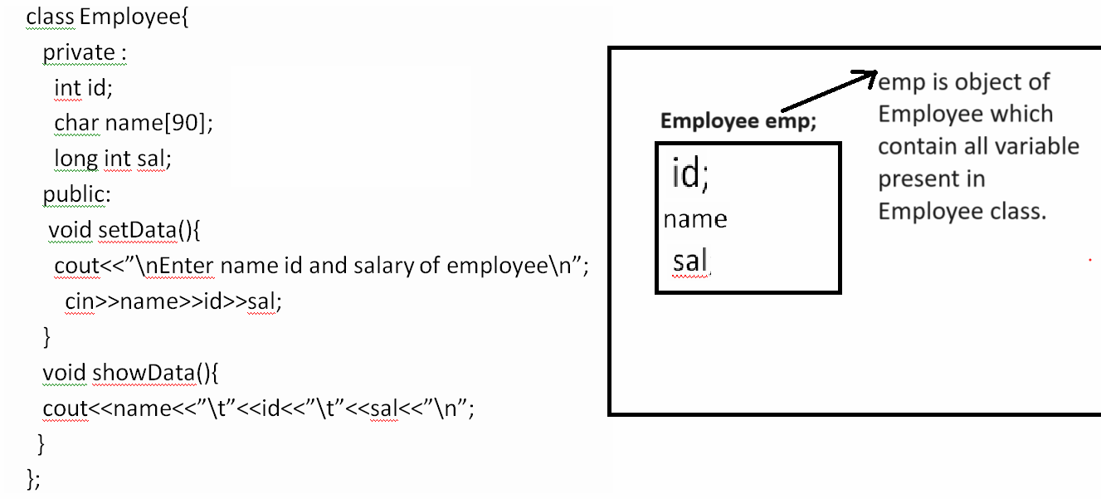
Note: once we create object of any class using that object we can access public member of class using
object.membername;

Steps to use any class in C++
_____________________________________________________________________
1. Declare class
_______________________________________________________________
class Add{
private:
int a,b;
public:

};

2. Define function within class
class Add{
private:
int a,b;
public:
void setData(){
cout<<”Enter two values”;
cin>>a>>b;
}
void showAdd(){
cout<<”\nAddition is “<<a+b<<”\n”;
}
};

3. Create object of class
void main()
{ Add ad; //create object of class

getch();
}

4. Call its public member using object.membername

void main()
{ Add ad; //create object of class
ad.setData();
ad.showData();
getch();
}

Following example shows the working of above code.
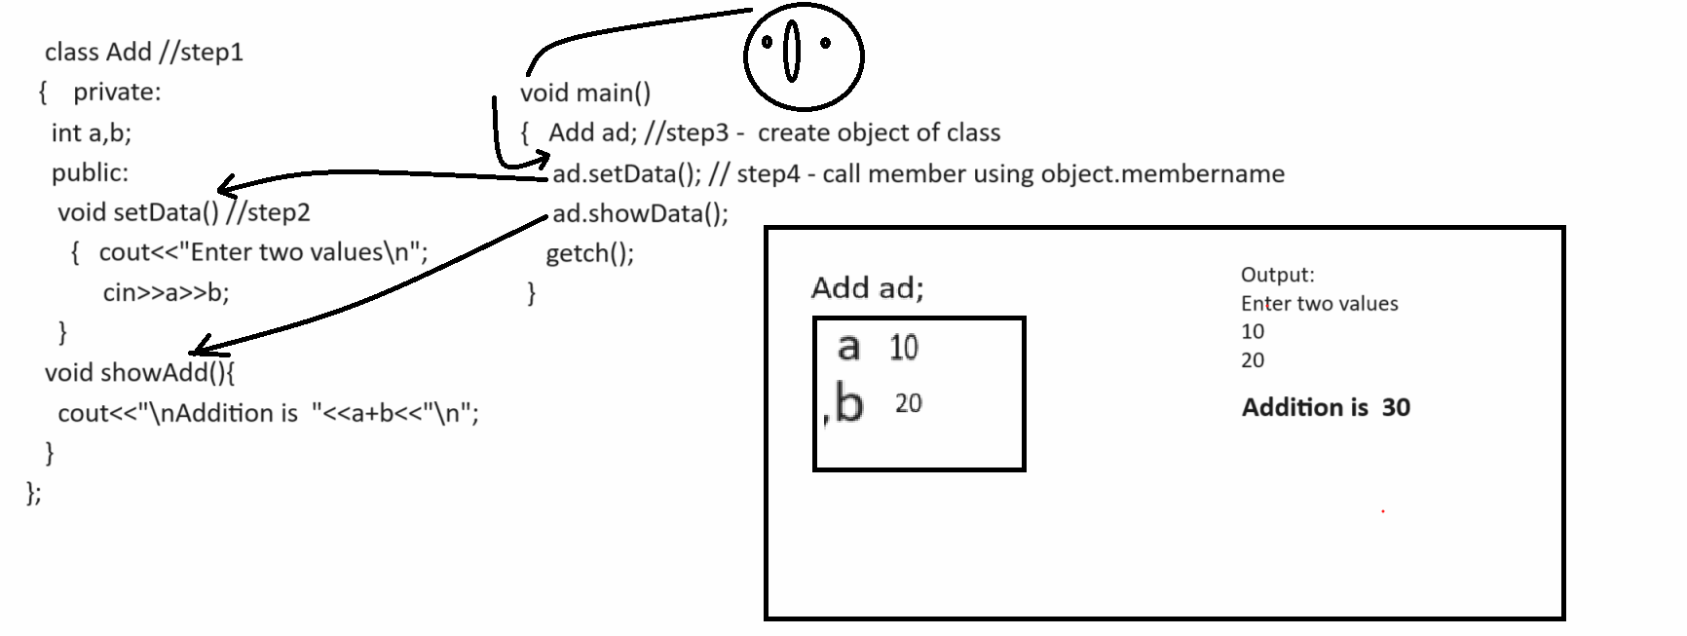

Example with source code.
#include<iostream.h>
#include<conio.h>
class Add //step1
{ private:
int a,b;
public:
void setData()//step2
{ cout<<"\nenter two values\n";
cin>>a>>b;
}
void showData()
{ cout<<"\nAddition is "<<a+b<<"\n";
}
};
void main(){
clrscr();
Add ad;
ad.setData();
ad.showData();
getch();
}

Example: WAP to create class name as Table with two functions
void setValue(): this function accept number from keyboard
void showTable(): this function can print the table of number.
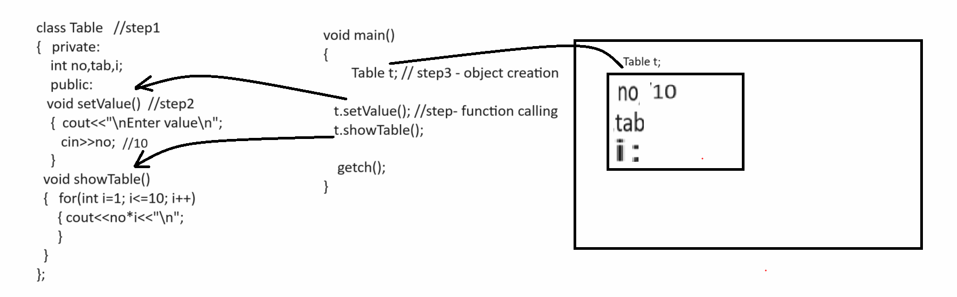

#include<iostream.h>
#include<conio.h>
class Table
{
private:
int no,i,tab;
public:
void setValue(){
cout<<"\nEnter number\n";
cin>>no;
}
void showTable()
{ for(i=1;i<=10;i++)
{ cout<<no*i<<"\n";
}
}
};
void main(){
clrscr();
Table t;
t.setValue();
t.showTable();
getch();
}

Example: WAP to create class name as Power with two functions
void setValue() : this function accept two values first as base and second as index
int getPower(): this function calculate power of number and return it.

Example: WAP to create class name as Factorial with two functions
void setValue(): this function accept number as parameter
int getFact(): this function can calculate factorial of number and return it.

Example: WAP to create class name as Reverse with two functions
void setNumber(): this function accept number as parameter from keyboard
int getReverse(): this function can reverse the number and return it.

How to pass parameter to class function
________________________________________________________________________________
When we pass parameter to call function then we need to copy the local variable value in instance variable of class or class variable.

Example: WAP to create class name as Square with two functions
void setValue(int x): this function accept integer as parameter
void showSquare(): this function can calculate square and display it.
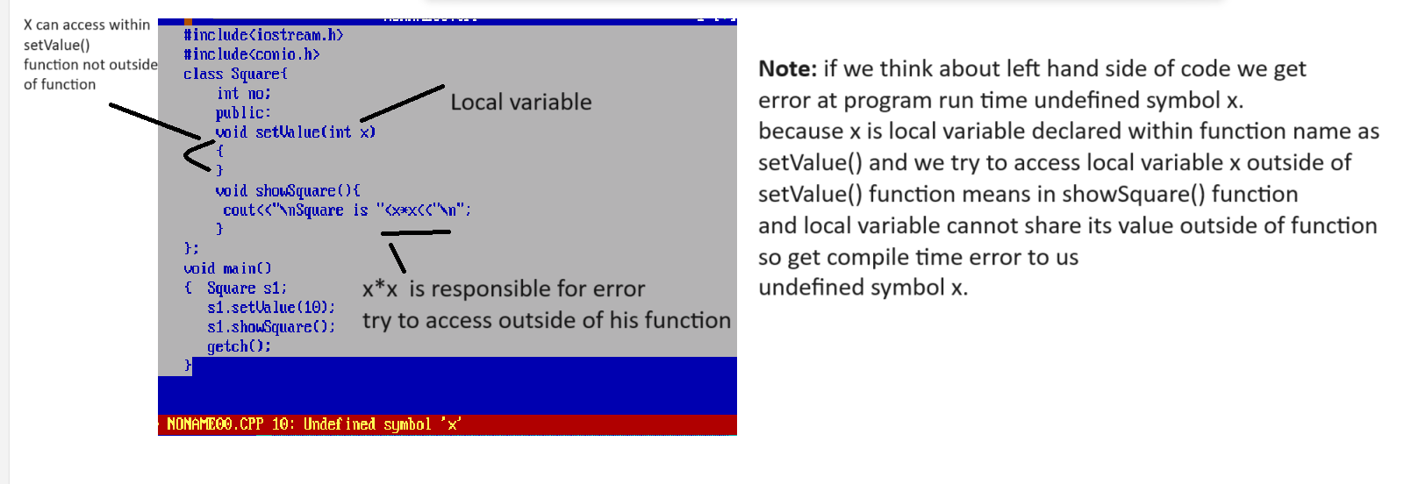
Note: if we want to solve above type of error then we need to copy the value of local variable in instance variable or variable declared within class as per our example we required to copy the value local variable x in to no because no is instance variable and instance variable can access all function of class shown In following diagram.
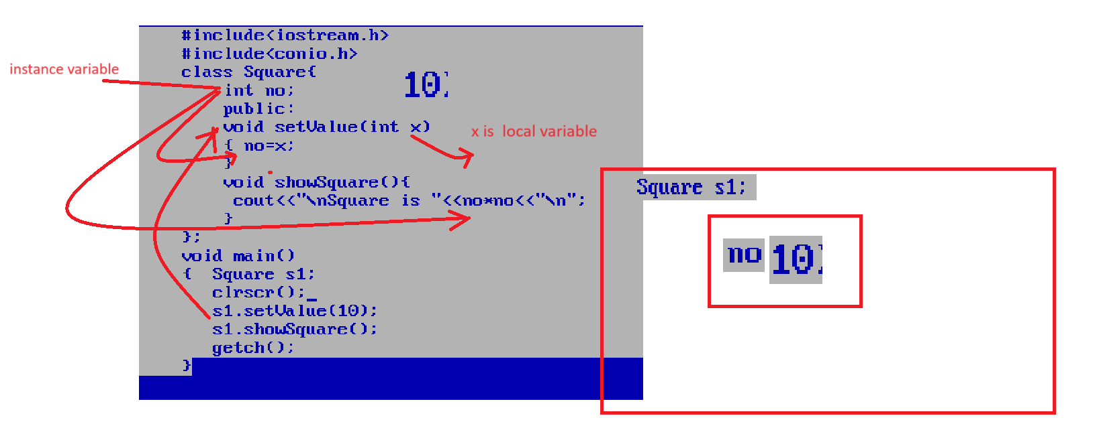
Example: WAP to create class name as Cube with two functions
void setValue(int no): this function can accept no as a parameter
int getCube(): this function can calculate cube of no and return it

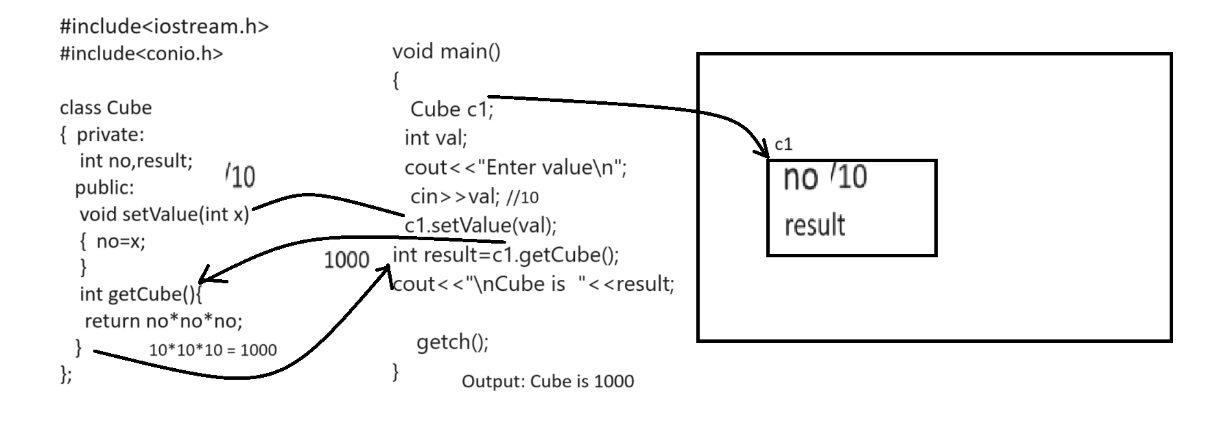
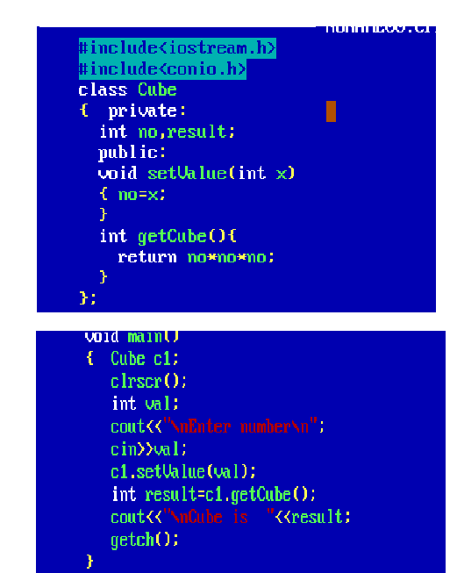

Example: WAP to create class name as Power with two function
void setBaseIndex(int base,int index): this function can accept two values base and index
int getPower(): this function can calculate power of number and return it.
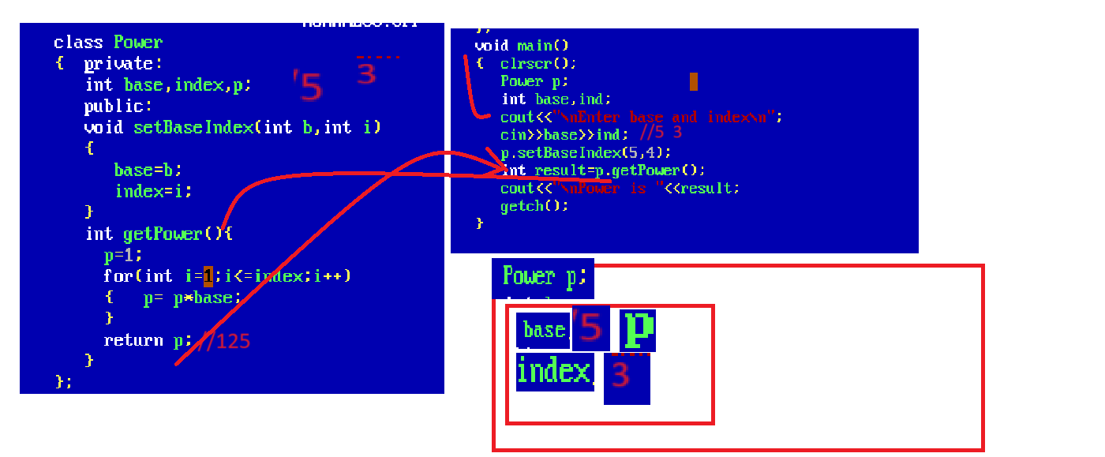

Exmaple: WAP to create class name as Factorial with two functions
void setValue (int no): this function accept integer as parameter
int getFactorial (): this function calculate factorial and return it.

How to pass array as parameter to class function
_____________________________________________________________________________
If we want to pass array as parameter to class function we have to pass base address of array in function and we need to declare on pointer as instance variable for store the base address of array.

Example: Suppose consider we have class name as Sum with functions
void setValue(int a[]): this function is used for accept array as parameter
int getSum(): this function can calculate sum of all values of array and return it.

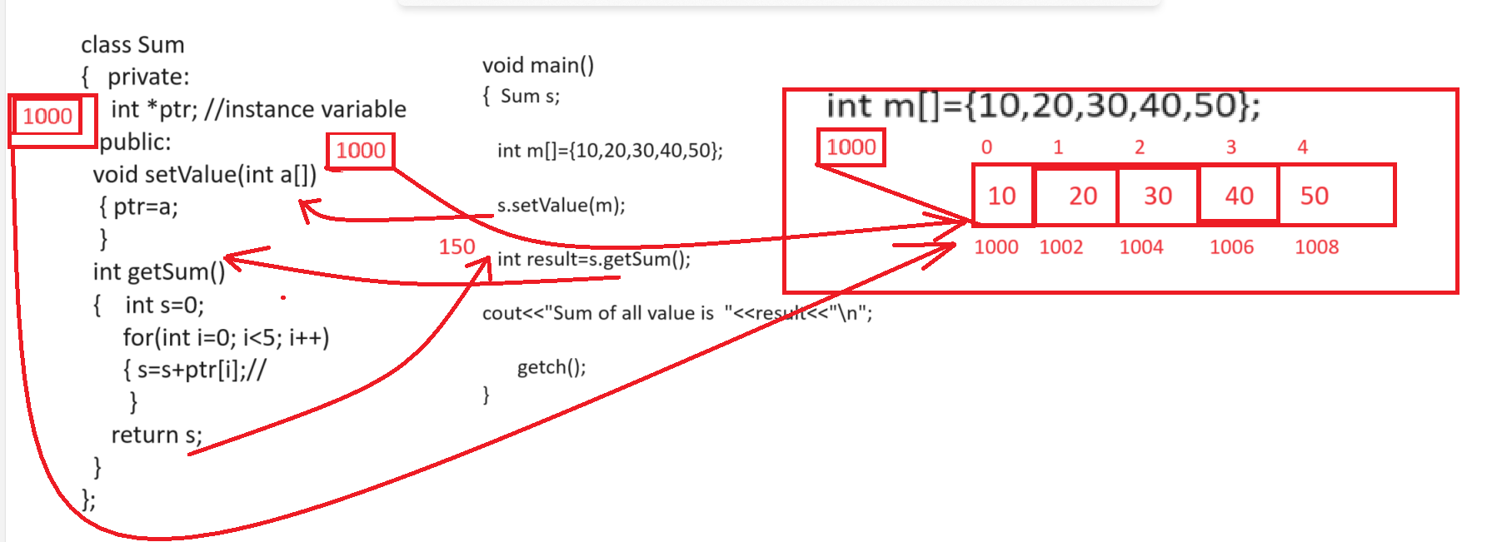

Example: WAP to class name as FindMax with two functions
void setArray(int a[]): this function is used for accept array as parameter
int getMax(): this function is used for find the maximum value from array and return it.

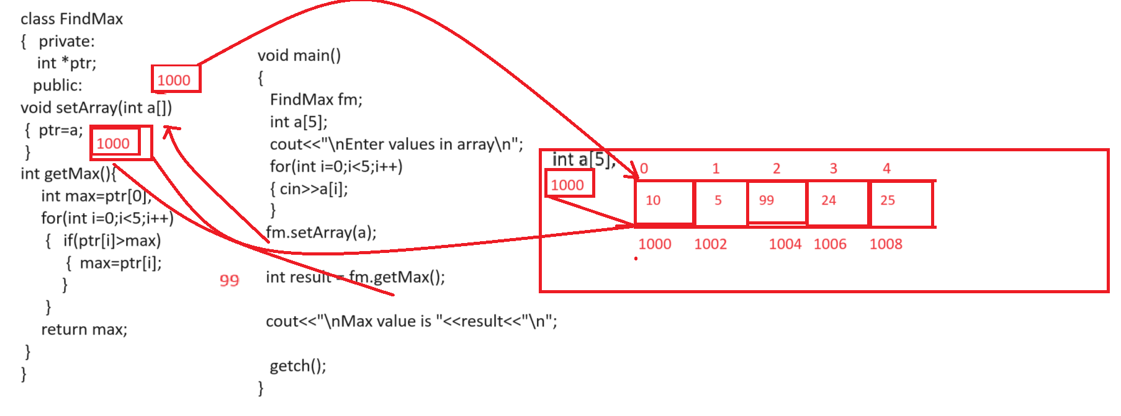

Example: WAP to create class name as ToUpperCase with two functions
void setCharArray(char[]): this function is used for accept array as input
void convertToUpperCase(): this function is used for convert your lower case string to upper case.

Note:if we want to pass string to the function as parameter then we have to ways to use string in class
A. by using strcpy() function
B. by using character pointer.
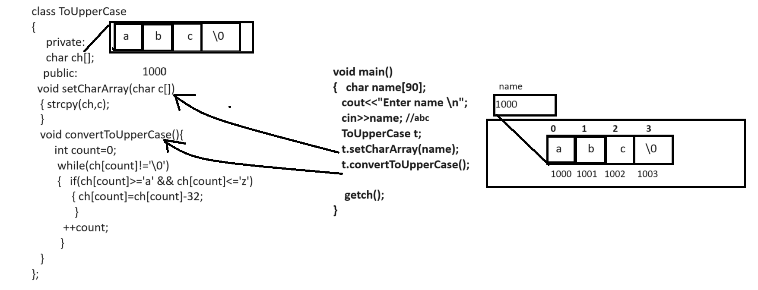

#include<iostream.h>
#include<conio.h>
#include<string.h>

class ToConvertUpper
{
private:
char ch[90];
public:
void setCharArray(char c[])
{ strcpy(ch,c);
}
void convertToUpperCase(){
int count=0;
while(ch[count]!='\0')
{
if(ch[count]>='a' && ch[count]<='z')
{
ch[count]=ch[count]-32;
}
++count;
}
cout<<"\nAfter conversion "<<ch;
}
};

void main(){
char name[90];
ToConvertUpper c;
cout<<"\nEnter name from string\n";
cin>>name;
c.setCharArray(name);
c.convertToUpperCase();
getch();
}

Example: WAP to create class name as FindLength with functions
void setCharArray(char[]): this function accept character array as input
int getLength(): this function can calculate length of string and return it.

Array of object
_________________________________________________________________________
Array of object is used for to store more than one object data in single name object called as array of object.
Example: Suppose consider we have class name as Employee with field id,name and salary and we want to create 5 employee object and display its data.
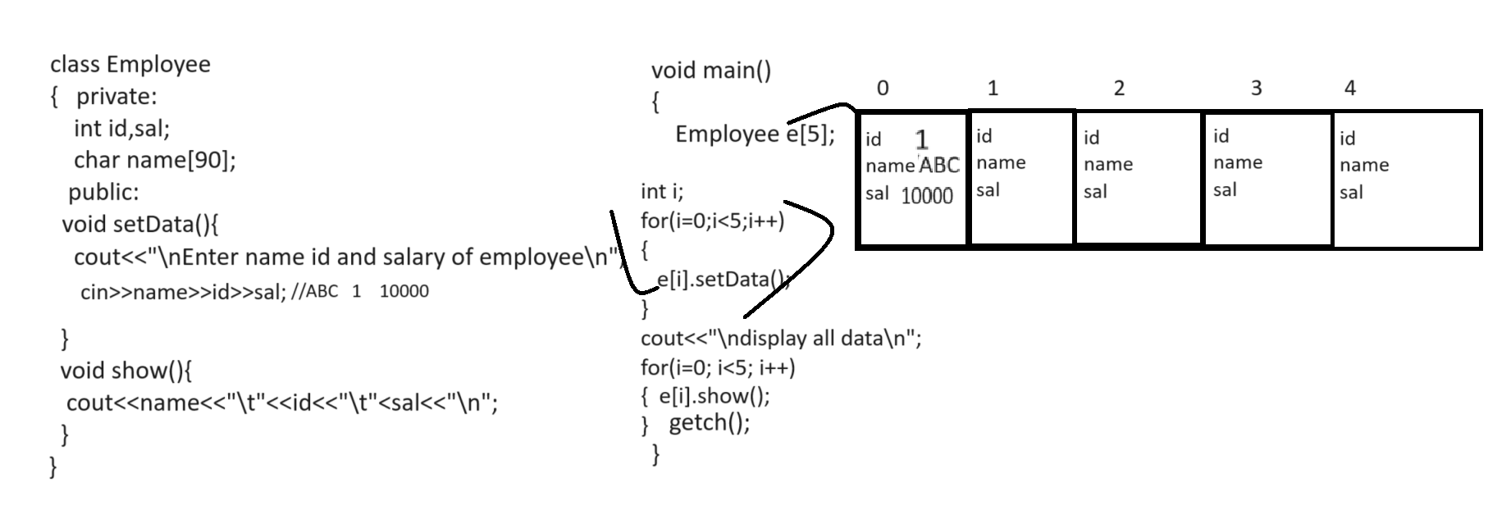

#include<iostream.h>
#include<conio.h>
#include<string.h>
class Employee
{
private:
int id,sal;
char name[90];
public:
void setData(){
cout<<"\nEnter name id and salary of employee\n";
cin>>name>>id>>sal;
}
void showData(){
cout<<name<<"\t"<<id<<"\t"<<sal<<"\n";
}
};
void main(){
Employee e[5];
clrscr();
for(int i=0;i<5;i++)
{ e[i].setData();
}
cout<<"\ndisplay all employee data\n";
for(i=0;i<5;i++)
{ e[i].showData();
}
getch();
}
If we use the array of object concept then we cannot allocate memory of object at run or cannot allocate dynamic memory of object so if we want to allocate memory dynamically we can use pointer with object.

Pointer of object
__________________________________________________________________________
Pointer of object help us to allocate memory of object at run time or allocate dynamic memory of object so when we use the pointer of object then we can use - >(arrow) operator for access class member
#include<iostream.h>
#include<conio.h>
#include<string.h>
class Employee
{ private:
int id,sal;
char name[90];
public:
void setData(){
cout<<"\nEnter name id and salary of employee\n";
cin>>name>>id>>sal;
}
void showData(){
cout<<name<<"\t"<<id<<"\t"<<sal<<"\n";
}
};
void main(){
clrscr();
Employee *e;
e->setData();
e->showData();
getch();
}

How to allocate dynamic memory of object at run by using pointer
____________________________________________________________________________
1. By using malloc () function: malloc function helps us to create run time array or dynamic array.
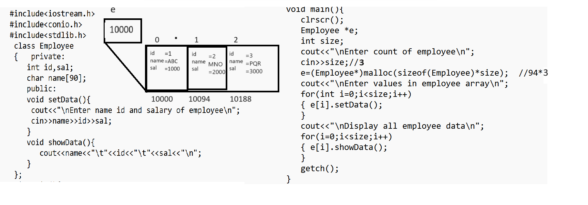

Q1. WAP to create class name as Sort with two methods
void acceptArray(int a[]): this function can accept array as parameter
void sort(): this function can sort the array in ascending order.

Q2. WAP to create class name as Reverse with two methods/function
void acceptArray(int a[]): this function can accept array as parameter
void reverse(): this function reverse the array and display it.

Q3. WAP to create class name as CompareString with function
void setString(char[],char[]): this function can accept two strings as parameter
int compareString(): this function compare two strings with each other and if strings equal return 0
otherwise return -1;
Note: do not use any inbuilt function for string comparision.

Q4. WAP to create class name as ExtractDigitFromString two methods
void setString(char[]): this function can accept string as parameter
void extractDigit(): this function can extract digit from string and display it.

2. By using new keyword in C++
__________________________________________________________________________
new keyword is used for allocate run time memory using C++ it is like as malloc
Note: using new keyword we can create dynamic array as well as we can allocate object memory.
Means we can say new keyword always work with pointer.

How to allocate dynamic array by using new keyword
______________________________________________________________________________
Syntax: datatype *variablename = new datatype[size];

Example: int * ptr = new int[5];
here we create array of type integer by using new keyword and ptr work as reference variable
Q. What is reference variable?
___________________________________________________________________________
Reference variable means variable which contain address of block or address of memory.

Example:
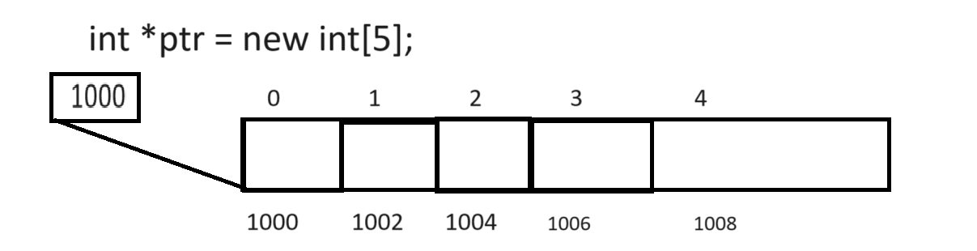
Note: if we think about above code we have reference variable name as ptr which contain base address
of array means ptr contain address so we can say ptr is reference variable
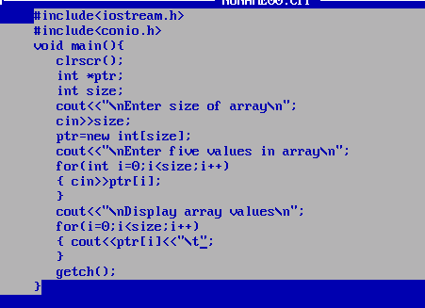

How to create object of class by using new keyword
_________________________________________________________________________
If we create object by using new keyword the benefit is we can allocate dynamic memory of object at run time and normally we want to work with call by reference with object then we can use pointer with object.

Syntax: classname *ref = new classname();
Example: Suppose consider we have class name as Employee then you can create its object like as
Syntax: Employee *emp = new Employee();

Here emp is reference of Employee class and new Employee() is actual object.

Q. what is difference between reference and object?
_______________________________________________________________________________
Reference is variable which hold address of object and object is block of memory where class data store shown in following diagram.
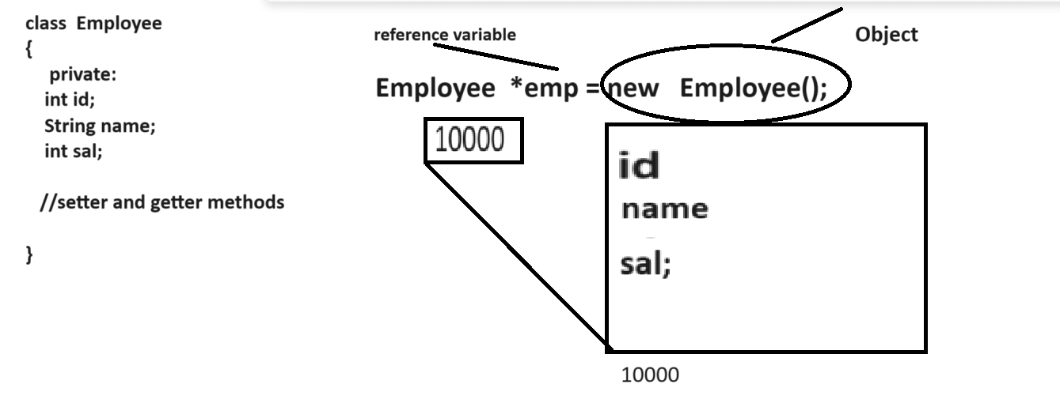
Note: if we think about above code we have statement Employee *emp = new Employee() here new Employee() is actual object and emp is reference variable because new Employee() create block in memory and which contain class data i.e id name and sal as per our example and emp contain address of that object so we can say emp is reference.
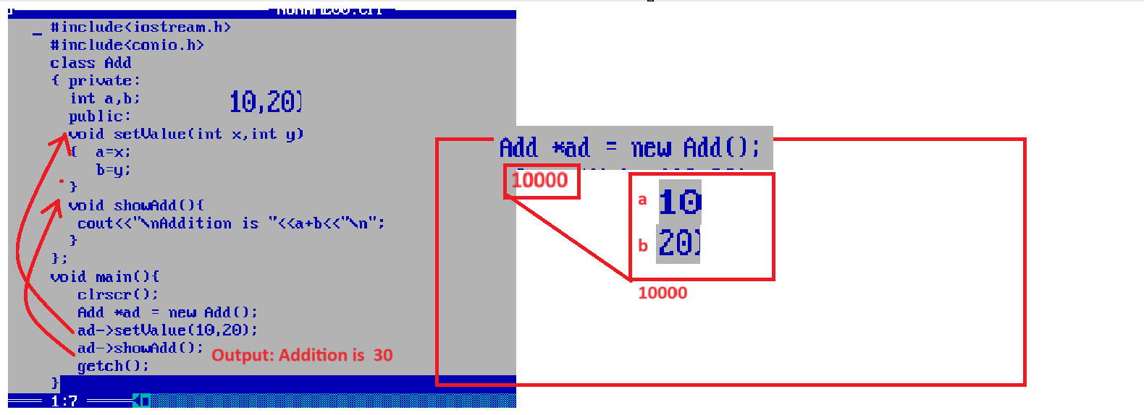
Q. What happen if we not use reference with object?
___________________________________________________________________________
if we to use reference with object then new keyword create new object every time known as anonymous object show in following diagram
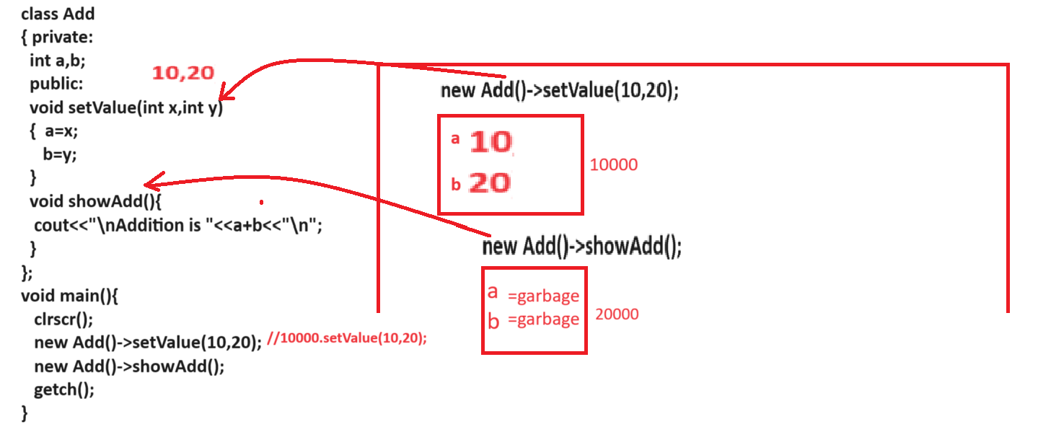
Note: if we think about above diagram we have main method and in main method we have statement
new Add()->setValue(10,20) here we have new object in memory whose address is 10000 and we call function setValue(10,20) by using object whose address is 10000 means we send 10 and 20 value on 10000 address means a=10 and b=20 on address 10000 again we have statement new Add().showAdd() means we create again new object in memory whose address is 20000 and we call function showAdd() by using object whose address is 20000 and in showAdd() we have statement cout<<”Addition is “<<a+b; but variable a and b contain garbage value because we provide value to variable a and b on address 20000 so we get answer Addition is garbage value
Means if we not reference with object then we can use object single time and if we want to reuse same object more than one time then we can use reference with object.

Note: without reference object known as anonymous object in programming

Q. Why use reference with object?
__________________________________________________________________
If we want to use same object more than one time then we can use reference with object shown in following code
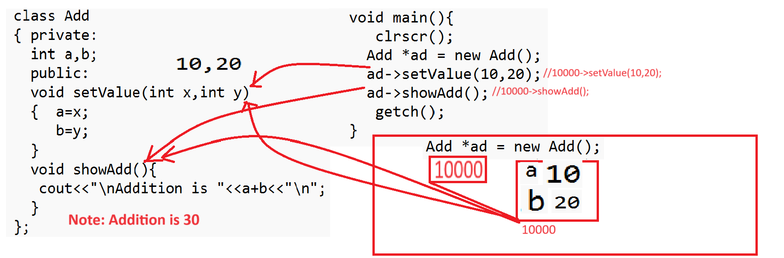
Note: if we think about above code we have statement in main Add *ad = new Add() here we have
ad is reference and new Add() is actual object whose address is 10000 and we store 10000 address in ad reference and we have statement ad->setValue(10,20) means 10000->setValue(10,20) we pass 10 and 20 on address 10000 and again we have statement ad->showAdd() here we not create new object we use object whose address present in ad means we use object whose address is 10000 so value a and b on 10000 is 10 and 20 so we have answer is Addition is 30

Q. Can we use more than one reference on single object?
________________________________________________________________________________
Yes we can use more than one reference with single object but there is possibility if we change the content of object using any one reference then object previous content may be lost shown in following code.
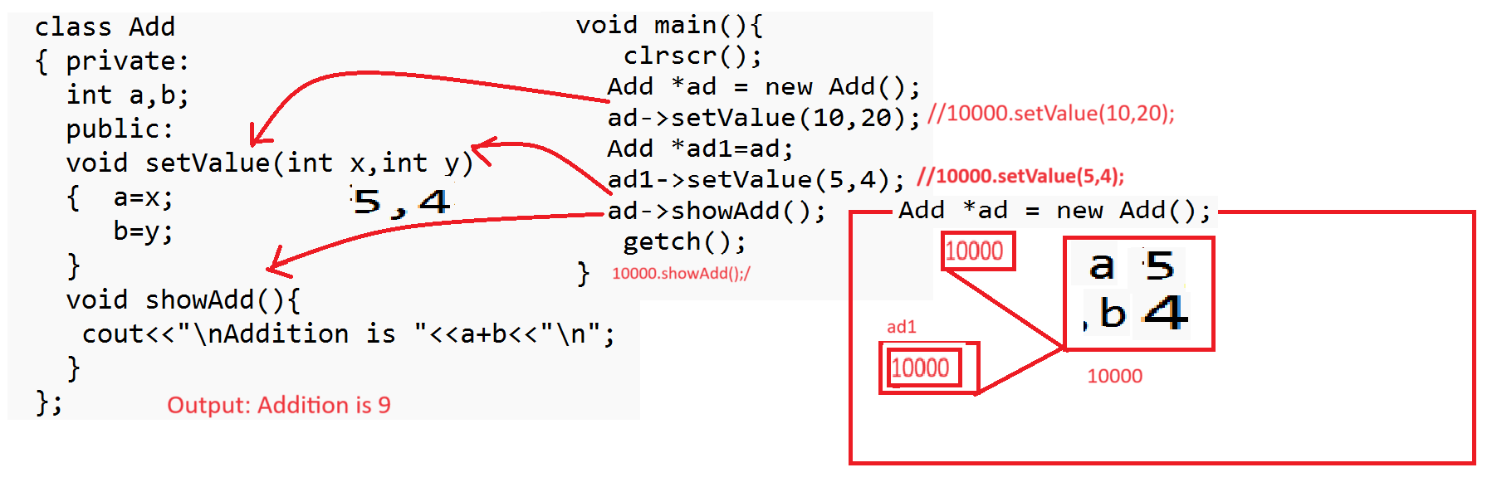
If we think about above diagram we have statement Add *ad = new Add(); means here we have ad is reference and new Add() is actual object and we consider object has address 10000 and we store this 10000 address in ad reference and we have statement ad->setValue(10,20) means we send these value on address 10000 means a=10 and b=20 and we have statement Add ad1=ad; means ad assign its value i.e 10000 address of object in ad1 means ad1 has address 10000 means ad and ad1 points to same memory or object and again we have statement ad1->setValue(5,4) means 10000->setValue(5,4) means we override 5 and 4 on 10000 address location means previous value of object set by ad reference get lost and we have ad->showAdd() means 10000->showAdd() so we get answer Addition is 9

Q. when create object without using pointer or using pointer or using new keyword?
_________________________________________________________________________________
When we want to work with call by value using object we have to use object without pointer and when we want to use call by reference with object then we can use object with pointer.
Note: before learn above concept we will discuss class with setter and getter methods
If we think about class setter and getter method using setter method we can store data in object and using a getter method we can retrieve data from object.
If we want to write setter and getter method in class then use set and get keyword before variable name and set method required parameter and get method can return value from function.
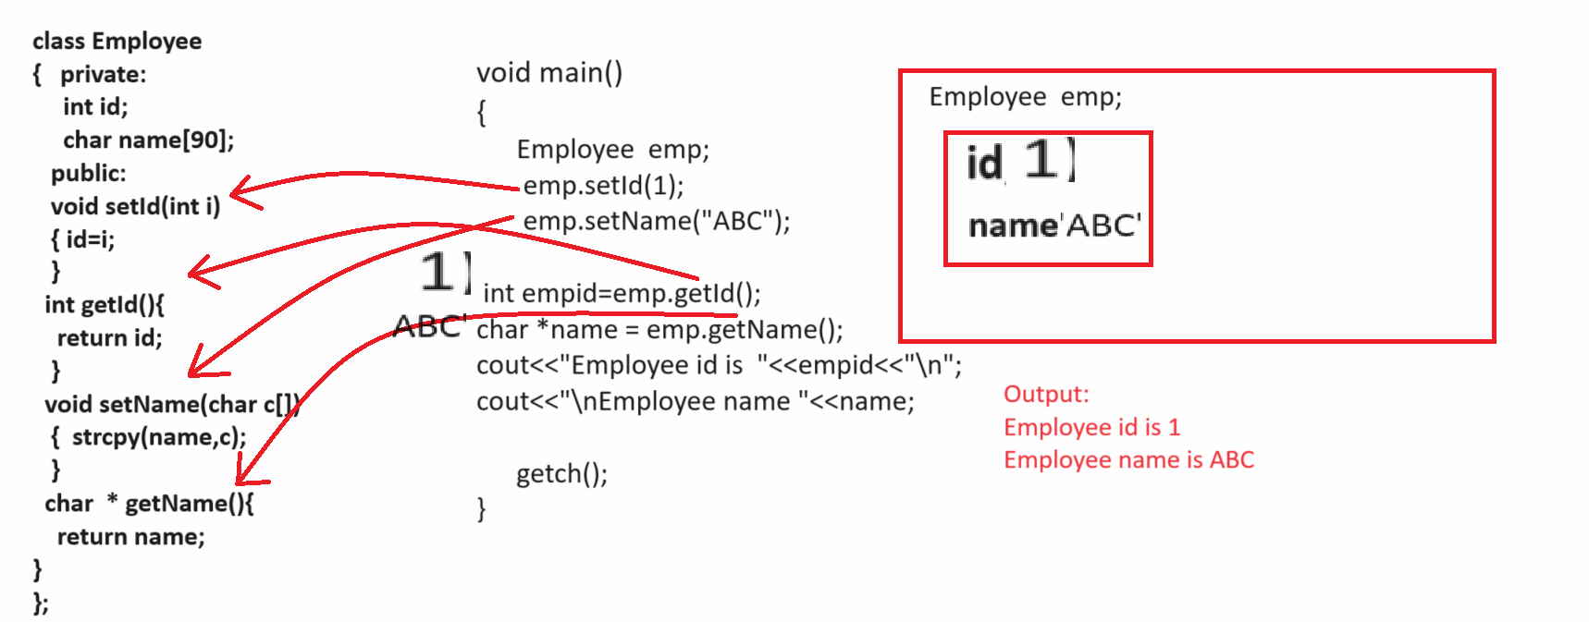

Example with source code
#include<iostream.h>
#include<conio.h>
#include<string.h>
class Employee
{
private:
int id;
char name[90];
public:
void setId(int i)
{ id=i;
}
int getId(){
return id;
}
void setName(char c[])
{ strcpy(name,c);
}
char *getName(){
return name;
}
};
void main(){
clrscr();
Employee emp;
emp.setId(1);
emp.setName("ABC");
int id=emp.getId();
char *n=emp.getName();
cout<<"\n\n\n\n\nId is "<<id<<"\n";
cout<<"\nName is "<<n<<"\n";

getch();
}

Example: WAP to create class name as product with id, name and price and create setter getter method
and input id name and price from keyboard stored in object and display it.
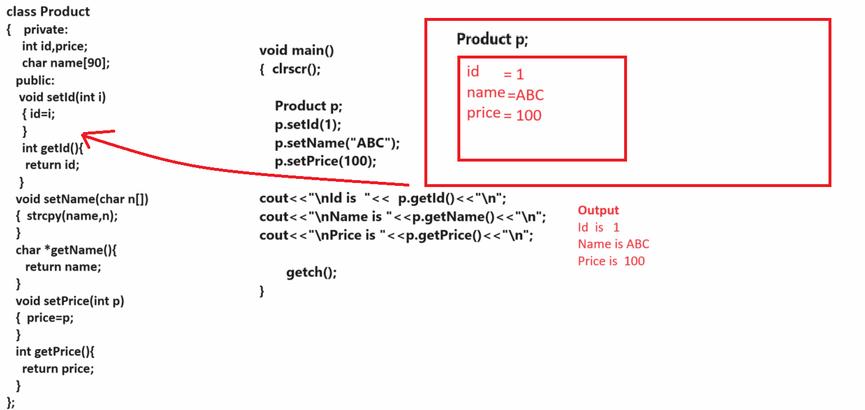

What is the purpose of setter and getter method or class with setter and getter method?
______________________________________________________________________________
We can setter and getter method class for passing object as parameter to other class function

Q. Why we need to pass object of one class as parameter in another class?
__________________________________________________________________________________
Some time if we have different kind of data in function as parameter and if we have large number of parameter present in function then passing single single parameter is not good approach so better way you can store all parameter in single class and pass class object as parameter because object contain data which is present in class means if we can say when we want to pass different type of data as parameter in function then we can pass object as parameter shown in following code.

Example function without object parameter
___________________________________________________________________________

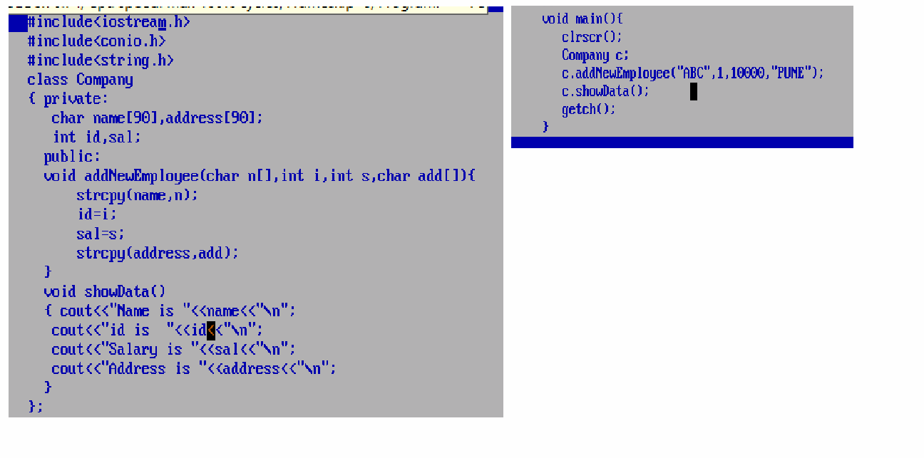
If we think about above code we have class name as Company with two functions
void addNewEmployee() which contain four parameters and when we call this function from main function then need to pass parameter from function calling point so Limitation of above function

a) Must be pass all parameters compulsory from function calling point
b) Need to remember the parameter sequence, its data type so it is very complicated when we have large number of parameter present e.g 50 parameter suppose we need to data employee using parameter like as name,id,sal, email,contact,address,dob,age,prevsal,exp,expsal,prevcomp,tenm,twlthm etc
so we required n number of parameter to function so it is not possible to remember this type of parameter sequence so better you can store all parameters in other class and pass class as parameter to function so the benefit is not need to remember parameter sequence and data type etc shown in following code as per our example we create one new class name as Employee and store four parameter in it id,name,sal and address and pass Employee object in Company class function name as
void addNewEmployee(Employee emp) herewe pass single parameter in function name as emp but emp contain four variables id,name ,address and salary because it is object of Employee class and object contain data which present in class shown in following code.
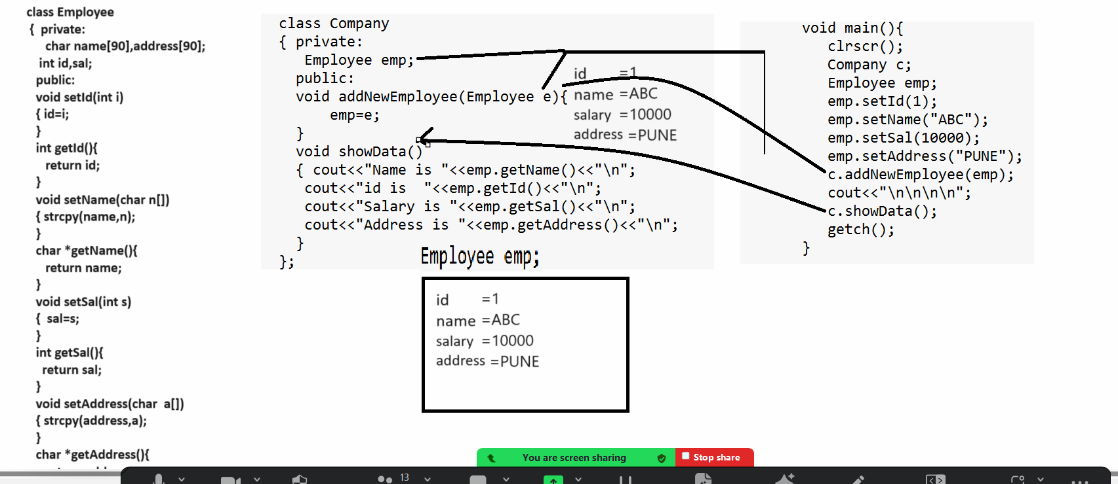

Source code
#include<iostream.h>
#include<conio.h>
#include<string.h>
class Employee
{ private:
char name[90],address[90];
int id,sal;
public:
void setId(int i)
{ id=i;
}
int getId(){
return id;
}
void setName(char n[])
{ strcpy(name,n);
}
char *getName(){
return name;
}
void setSal(int s)
{ sal=s;
}
int getSal(){
return sal;
}
void setAddress(char a[])
{ strcpy(address,a);
}
char *getAddress(){
return address;
}
};
class Company
{ private:
Employee emp;
public:
void addNewEmployee(Employee e){
emp=e;
}
void showData()
{ cout<<"Name is "<<emp.getName()<<"\n";
cout<<"id is "<<emp.getId()<<"\n";
cout<<"Salary is "<<emp.getSal()<<"\n";
cout<<"Address is "<<emp.getAddress()<<"\n";
}
};
void main(){
clrscr();
Company c;
Employee emp;
emp.setId(1);
emp.setName("ABC");
emp.setSal(10000);
emp.setAddress("PUNE");
c.addNewEmployee(emp);
cout<<"\n\n\n\n";
c.showData();
getch();
}

Assignments
Q. WAP to create class name as Product with three field id,name and price and create setter and getter methods and we have one more class name as Shop with two methods
void setProduct(Product): this method accept product class object as parameter
void showProduct(): this method can show the product details.

Q. WAP to create class name as Course with field id,name,fees and write setter and getter method
and create one more class name as Institute with two methods
void setCourses(Course c[]): this function accept course class object array as parameter
void showCourse(): this function show the all courses

Q. WAP to create class name as MergeArray with two functions
void setArray(int a[],int b[]): this function can accept two array as parameter
void mergeArray(): this function can merge two array and store in third array and display it.

Instance variable and class variable/static variable
__________________________________________________________________________________
Q. what is meaning of instance variable and class variable?
_________________________________________________________________________________
Q. what is instance variable & class variable?
________________________________________________________
Those variables declare within class but without static keyword called as instance variable and those variable declared within class with a static keyword called as class variable.
Example
class ABC
{ public:
int x;// instance variable
static int y; //class variable
};
If we want to work with instance variable and class variable we have some important points.
1. Instance variable allocate its memory after creating object and static variable allocate its memory before creating object of class. The meaning of this statement is instance variable present in object and static variable is not present in object means static variable is not part of object and static variable stored within data segment of memory.

How we can prove instance variable present in object and static variable is not present object?
_________________________________________________________________________________
If we want to prove this you can size of object because object size is dependent on variable declared within class.
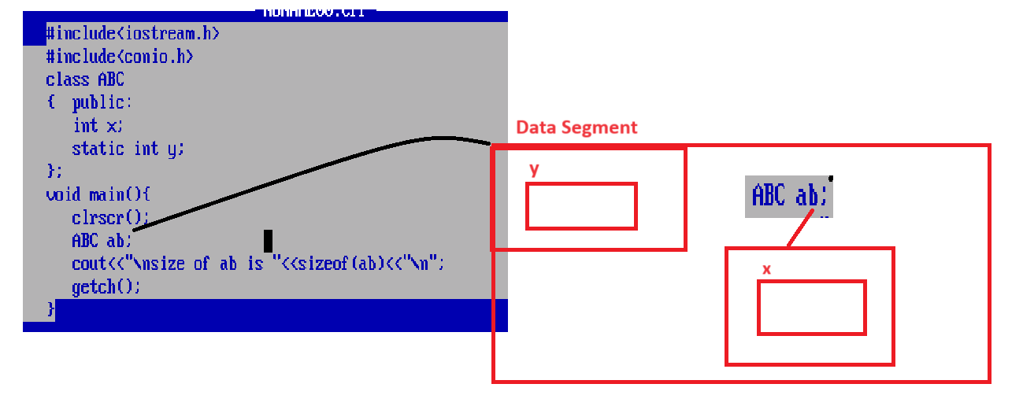
Note: if we think about above diagram and class we have two variables name as x and y and x is instance variable and y is static or class variable and when we create object of the class then x present in object and y allocate memory before creating object in data segment of memory.
static variable not present in object so we can use static variable by using classname :: resolution operator.
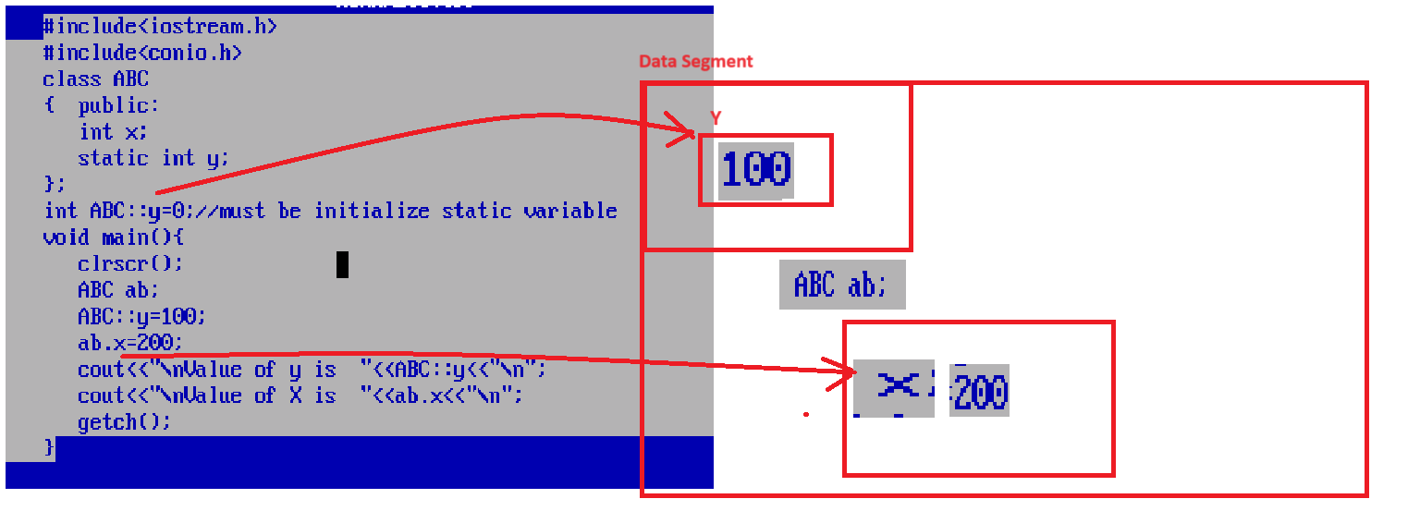
2. static variable can access by object and classname:: but instance variable can access only using object.
3. static variable share its common copy between more than one object of same class but instance variable share separate copy between every object of class.

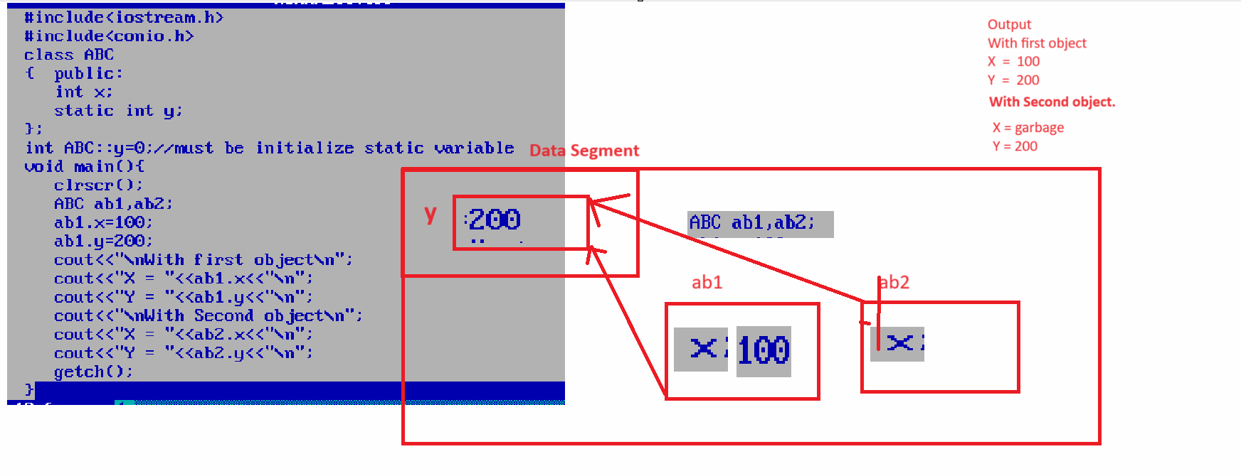
If we think about above code we have class which contain one static variable and one instance variable and static variable in data segment of class and its initial value is 0 and we create two object in main method ABC ab1,abc2 means we have two block in memory one is ab1 which contain x variable and ab2 which contain x variable means we have two copies of x in memory but only one copy of y variable in data segment of memory as per memory diagram and we have statement ab1.x=100 so this 100 initialize in x who present in ab1 and ab1.y=200 means this value present in y which is present in data segment of memory and we have statement cout<<”with first object”; here ab1.x print X = 100 and ab1.y =200 print Y is 200 and again we have statement cout<<”With second Object “; ab2.x print garbage value because we not initialize value to ab2.x but we have Y is 200 because y is common between ab1 and ab2 if ab2 not set value in y but ab1 set value in y before use by ab2 so we get answer Y is 200.

static function
_________________________________________________________________________
static function means function can define by using static keyword and static function can call by using classname:: operator
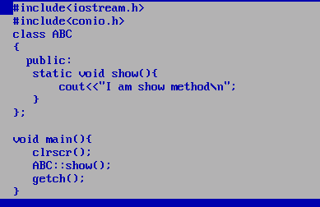
Note: you can also call static function by using classname and object name also.
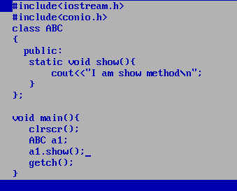

Note: static function can use only static variable we cannot use non static variable in static function.

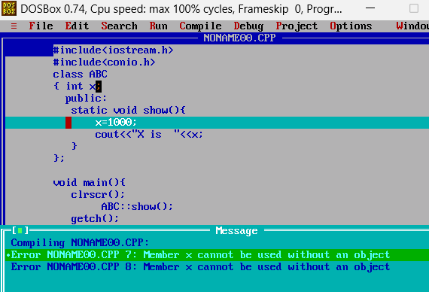
Note: if we think about above code we have error at compile time Member x cannot be use without an object because x is instance variable and we use it in show() function and show() is static function so
static function can allocate memory before creating object of class and x cannot allocate memory without object so we get error so this is major we cannot use instance variable in static function so if we want to avoid this problem or resolve this problem we can required to declare x as static
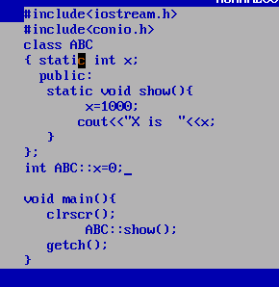
Local variable
__________________________________________________________________
Local variable means variable declare within function called as local variable
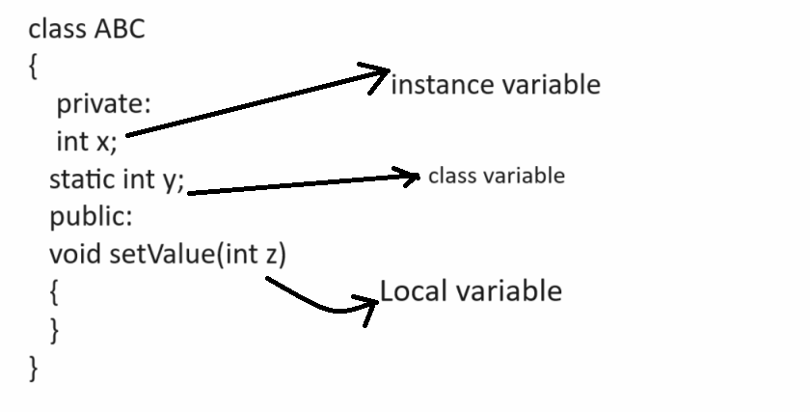

If we want to work with local variable we have some important points given below.
1. Local variable cannot access outside of his block or function so if we want to access the
Local variable outside of his function or block we need to copy its value in to instance variable.
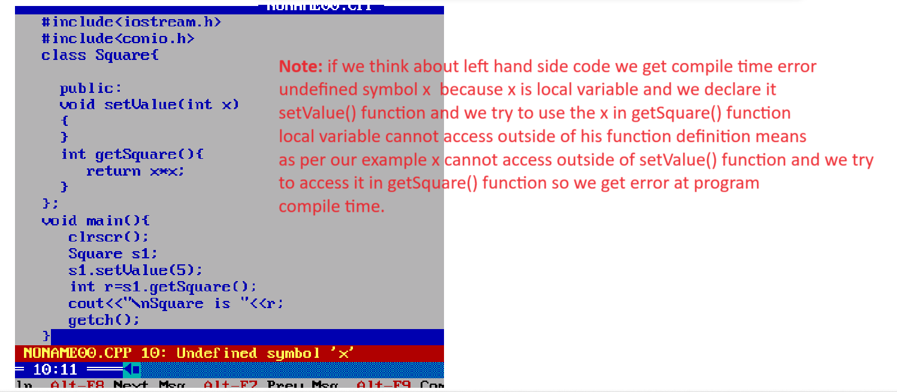
So if we want to resolve this problem we need to copy the local variable value in to instance variable shown in following code.
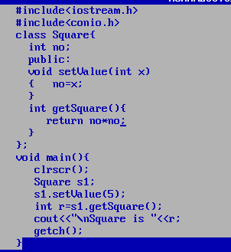

2. If instance variable and local variable name is same then instance variable not access in function where local variable name is same.

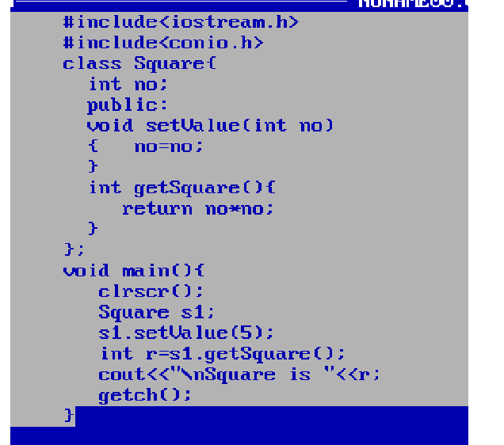
Note: if we think about above code we get garbage value as answer because we have same name instance variable and same name local variable so if we want to solve this problem we can use this reference.

Q. what is this reference?
_____________________________________________________________
This is internal reference present in every class which is used for point to current running object in memory. Current running object means function calling object called as current running object shown in following code.
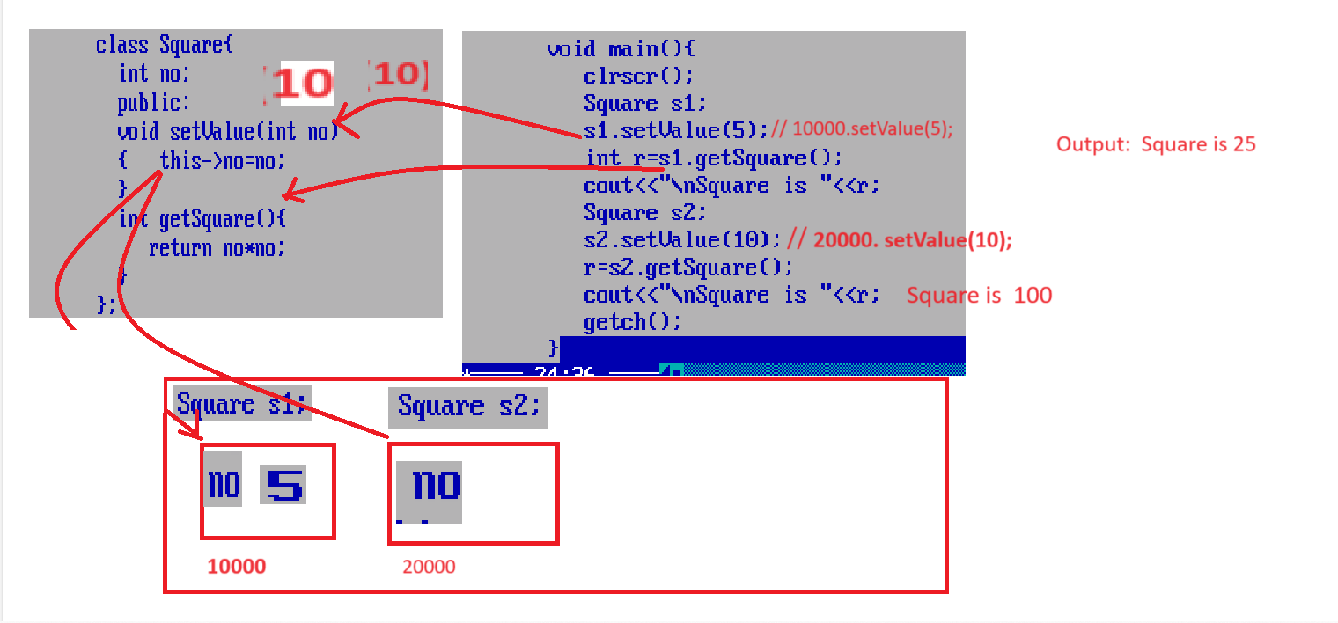

How to define function outside of class
________________________________________________________________
If we want to define function outside of class then we have to use scope resolution operator (::)
Syntax:
return type classname:: functionname(datatype variablename)
{ write here your logics
}
:: Here scope resolution operator specify member belongs from which class.
Example:
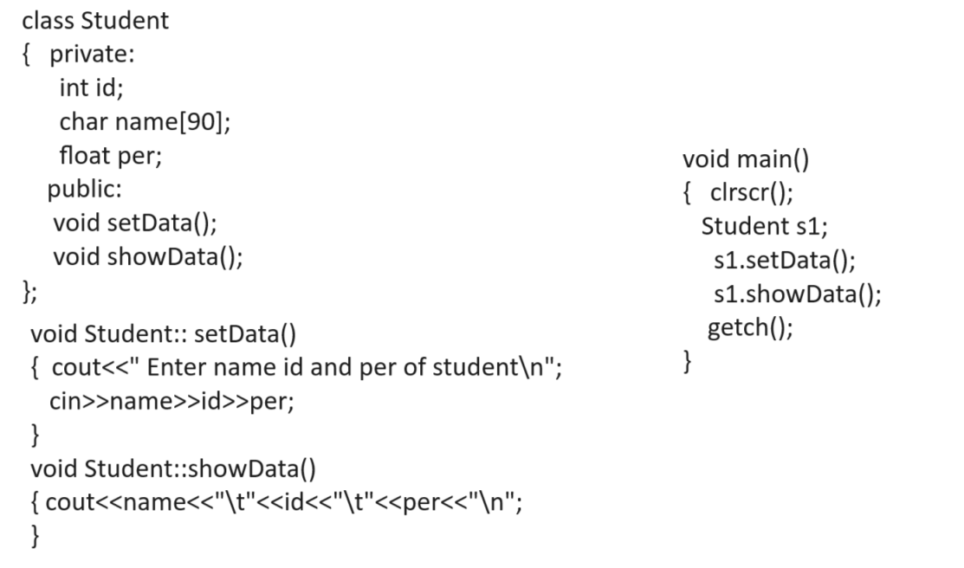

Example with source code
#include<iostream.h>
#include<conio.h>
class Student
{ private:
int id;
char name[90];
float per;
public:
void setData();
void showData();
};
void Student::setData()
{ cout<<"\nEnter name id and per of student\n";
cin>>name>>id>>per;
}
void Student::showData()
{ cout<<name<<"\t"<<id<<"\t"<<per<<"\n";
}
void main()
{ clrscr();
Student s1;
s1.setData();
s1.showData();
getch();
}

Q. Why we need to define function outside of class?
____________________________________________________________________________
If we define function within class then function consider as inline function

Q. what is inline function?
________________________________________________________________________
Inline function means function can use for smaller logics and inline function can faster than regular function

Syntax: inline return type functionname(datatype variablename)
{ Write here your logics
}

Q. What is scope resolution operator?
____________________________________________________________________________
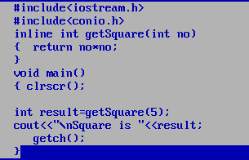
If we want to work with inline function we have some important points
1. Try to avoid write larger logics or big logics in inline function
2. Try to avoid write loop or recursion in inline function
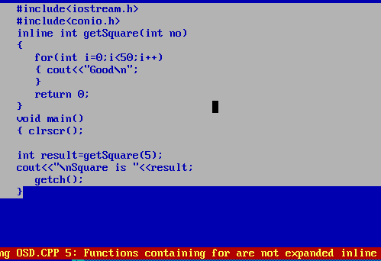
If we think about above code we get warning because we try to write larger code in inline function.

3. Provide encapsulation.

